Lecture Notes: Operating Systems - Simplified : Lec 2

# OS Goals

• Maximum CPU utilization

• Less process starvation

• Higher priority job execution

# Types of Operating Systems

**Single process Operating System -**only 1 process executes at a time from the ready queue. [Oldest]

## Multiprogramming Operating System

Formal Definition: A system where multiple jobs (code and data) are kept in memory to maximize CPU utilization. It ensures that the CPU always has something to execute when a job is waiting for I/O.

Layman Explanation: Imagine you have a few tasks to do, like cooking and cleaning. While the water is boiling (waiting), you clean the dishes (another task), so you don’t waste time doing nothing.

Key Features:

• Single CPU, but context switching between processes

• Switches tasks when the current process goes into a wait state

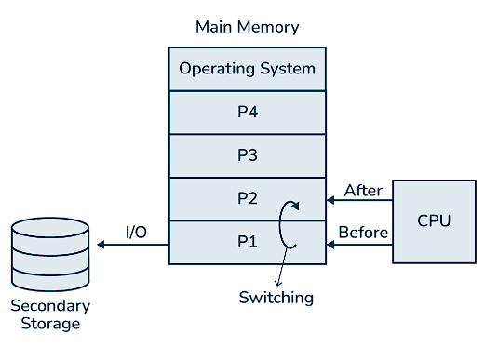• Reduces CPU idle time

Fig 1 - multiprogramming OS

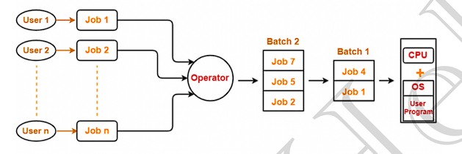 Fig1 – batch processing OS

## Batch Processing Operating System

Formal Definition: A system where jobs are prepared and grouped into batches, which are then executed one by one.

Layman Explanation: Imagine you submit your assignments in a pile along with others. The teacher picks up the pile and grades each one in order, but cannot prioritize any one assignment.

Key Features:

• No priority setting, may lead to process starvation

• CPU might become idle during I/O operations

## Multitasking Operating System

Formal Definition: A logical extension of multiprogramming that allows a single CPU to execute multiple tasks at the same time, using time-sharing and context switching.

Layman Explanation: Imagine switching between multiple tabs on your browser. Each tab gets attention, but only one is active at a given moment.

Key Features:

• Single CPU, can run more than one task simultaneously

• Reduces CPU idle time, increases responsiveness

## Multi-processing Operating System

Formal Definition: A system that uses more than one CPU in a single computer, increasing reliability and throughput by having multiple CPUs work on different processes simultaneously.

Layman Explanation: Imagine having two chefs in a kitchen. If one chef is busy, the other can take over another task.

Key Features:

• More than one CPU

• Increases reliability and process throughput

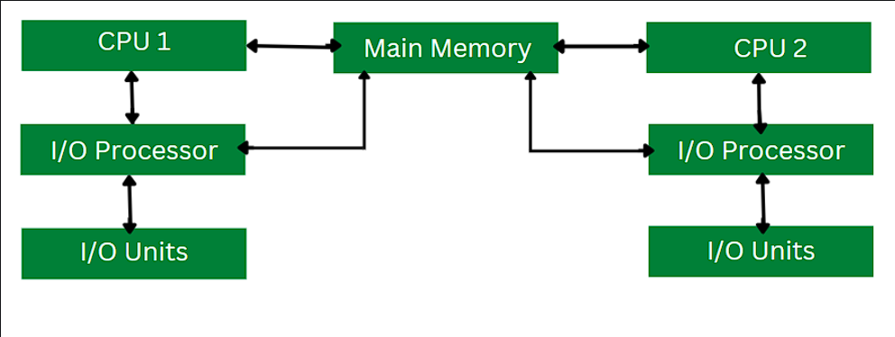

Fig 1 – multiprocessing OS

## Distributed Operating System

Formal Definition: An operating system that manages a collection of independent, networked, and communicating computers that appear to the user as a single coherent system.

Layman Explanation: It’s like a group of friends working on a project together from different locations but appearing to work as one team.

Key Features:

• Manages many resources across multiple nodes

## Real-Time Operating System (RTOS)

Formal Definition: A system that processes data as it comes in, typically for systems that require timely and error-free computations, like air traffic control or robotic systems.

Layman Explanation: Imagine a robot that needs to stop instantly if it sees an obstacle – it must react in real-time without delay.

Key Features:

• Tight time boundaries

• Used in critical applications like robots, air traffic systems